**MRI zero**

**6.4.2019 – 2**

**6.4.2019 - 1**

**Still struggling with the ADCs and gradmoms**

* Pulseq also has some errors when sending zero grad events. Fucked up some lines in my case.
* we now use the convention that ADC is acquired first.
* Pulseq still requires a full gradient until the end of the sampling ( so 16 gradient steps for 16 resolution) not only 15
* Thus in the sequence files we actually change nothing, also not the ADC mask. The ADC first is in the scanner class, but should be transparent.
* Old all_iters can still be exported as the sequence definition did not change. Actually only the adjoints needed for the reco will change when used with gradmoms from sim. Gradmoms form pulseq should be as well transparent.

**ADC is always on until the end of the read gradient:**

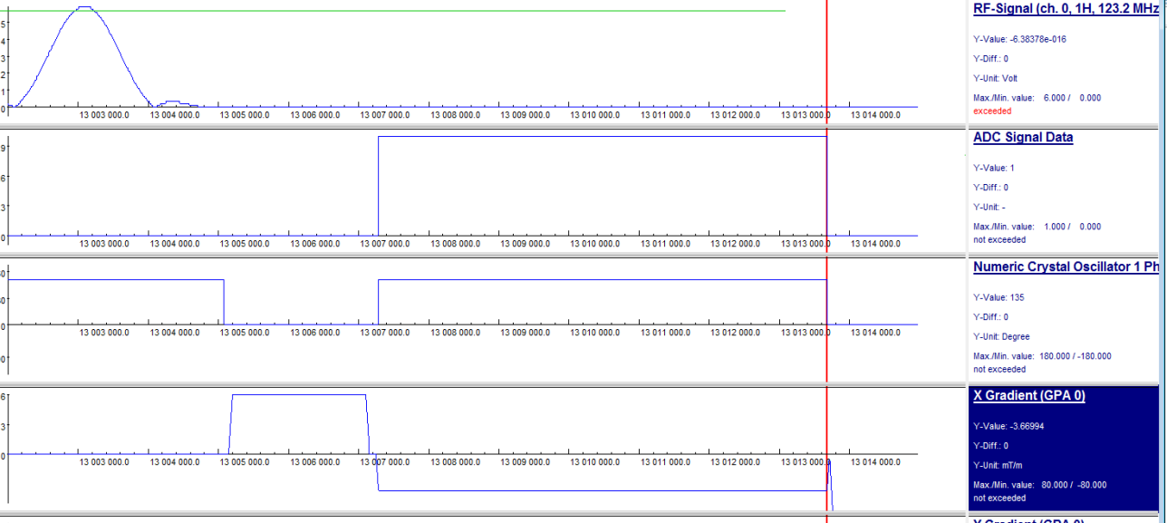

**03.04.2019**

Figures in: seq190402__e06_tgtGRE_tsk_GRE_no_grad_16_1kspins_lr0.7_onlyrewind

We made the following observation:

The gradient moments seem off for some reason.

Using the adjoint with the gradmoms given in pulseq actually solved the problem

**27.03.2019**

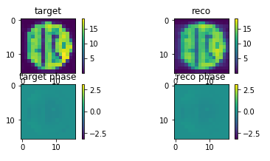

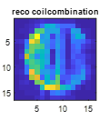****

**Left GRE, right lowSAR GRE**

**Numerical phantom added from measured 2D phantom.**

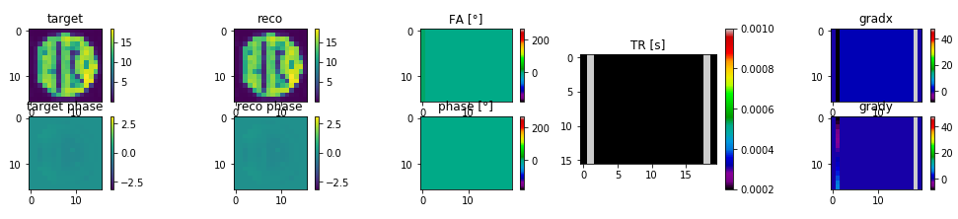

**check for spoiling here: Nspins min 25^2**

**Div by sz-1**

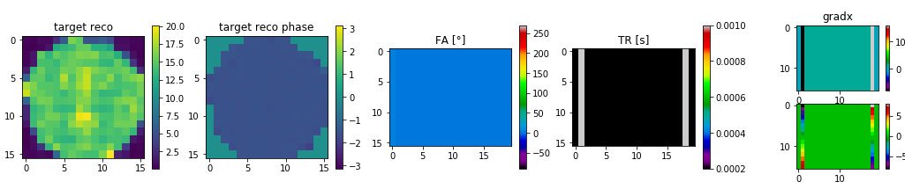

**Div by sz**

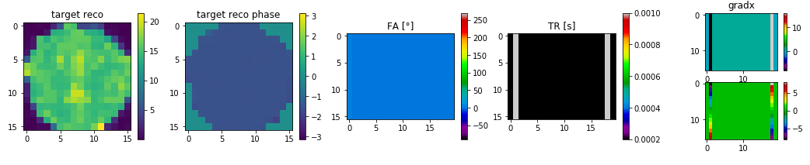

**12^2 spins**

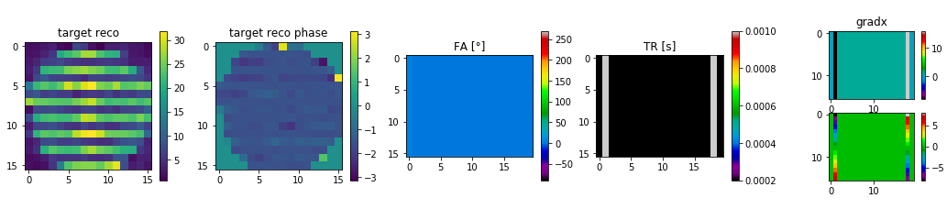

**Spin distribution within voxel, off=0**

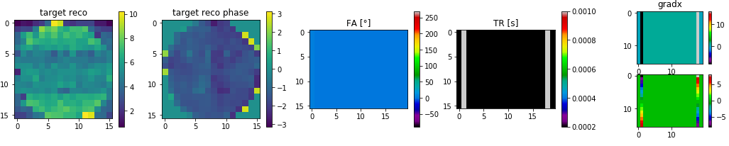

**Spin distribution within voxel, off=1/dim**

**26^2 spins**

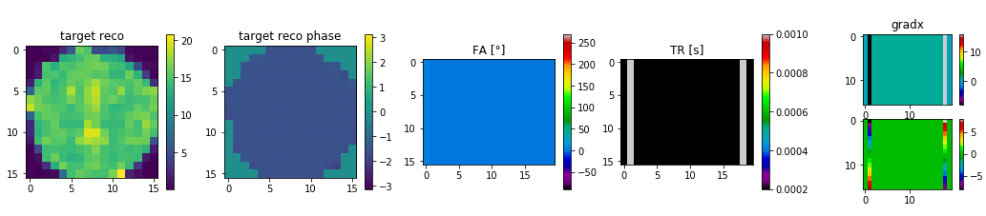

**Spin distribution within voxel, off=0**

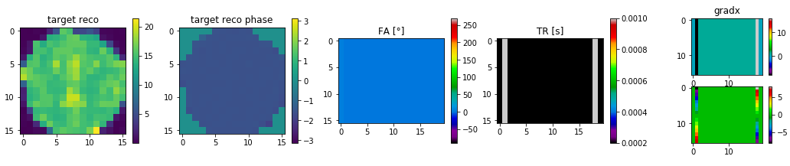

**Spin distribution within voxel, off=1/dim**

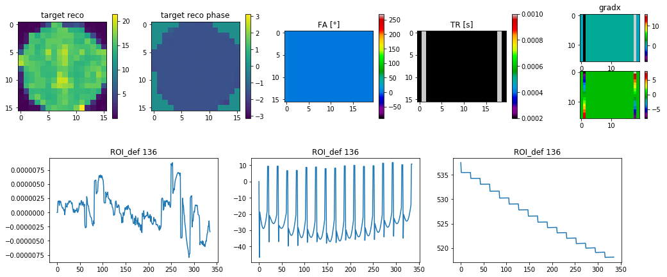

**Spoiled GRE: With pervec**

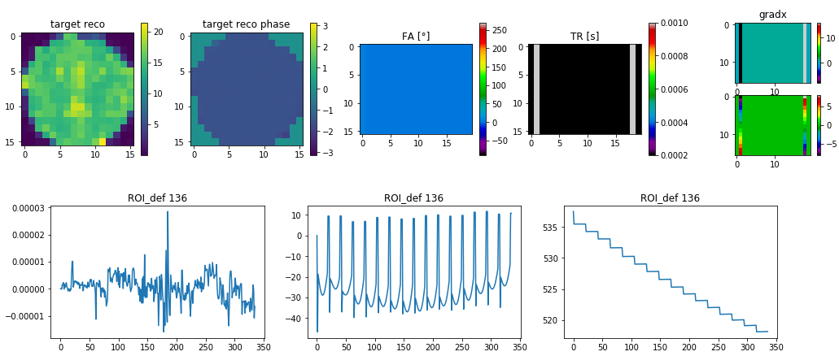

**Spoiled GRE: Without pervec**

**27.03.2019**

**Low SAR GRE optimized**



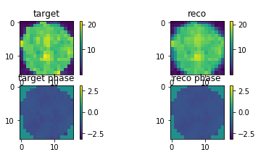



**Hooray!**

**26.03.2019**

**Try the following experiments:**

1. spoiled GRE (RF and gradient) x2negy****
2. **spoiled GRE (RF spoiled x2y2**



1. unspoiled GRE (Rf spoiled, no gradient)



1. **unspoiled (no grad, no RF)**



**25.03.2019**

found problem deep in sumulation: we modeled until now deltafunction, now change to continuum

**11.03.2019 – RARE 2D with spoilers added**

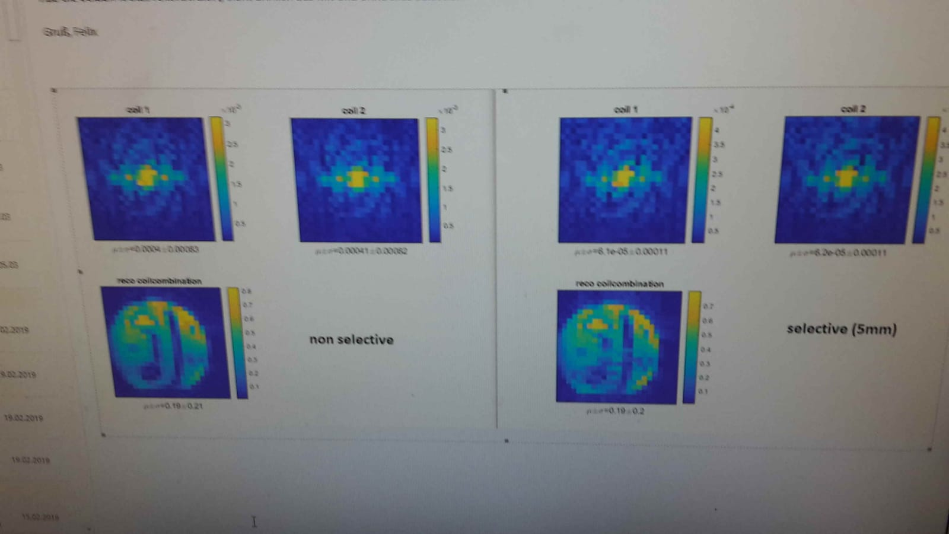

**11.03.2019 – first RARE 2D results – no spoilers**

